BPSO iCompute Final Challenge

5th Grade

Name: ______________________________________

Theoretical Computing
1. (5 points) Complete the following table

Binary | Decimal
11 | 3 (Example)
1111101
 | 94

2. (5 points) Draw a flow chart on the back of this test that does determines whether a four-sided shape is a rhombus, square, parallelogram, rectangle, or trapezoid. If a shape can be called more than one thing (a parallelogram AND a rectangle, for example), it should be called the most specific thing it can be (the shape with the most rules). If it is none of the listed shapes, the shame should be called a blob. Assume the angles and sides of the quadrilateral are labeled as in the figure below. You can test to see if angles or sides are of equal length, if sides are parallel to each other, and if any angle is a right angle.

Here are the definitions for each shape:
- rhombus: all sides are of equal length
- square: all sides are of equal length and all angles are right angles (90°)
- parallelogram: opposite sides are parallel to each other and are of the same length
- trapezoid: two opposite sides are parallel, and the other two sides are of equal length.
- rectangle: opposite sides are parallel and equal, and all angles are right angles (90°)
- blob: a four-sided shape that is not a rhombus, square, parallelogram, trapezoid, or rectangle

A
B
C
D
CD
BC
AB
AD

Practical Computing

3. (30 points) Create a game in Scratch in which the player controls a “launcher” with the left and right arrow keys and the spacebar. The goal is to hit a target that is moving back and forth across the top of the screen. Points are scored each time the ball/missile hits the target. The game should get slightly more difficult as more points are scored (though how it gets more difficult is up to you).

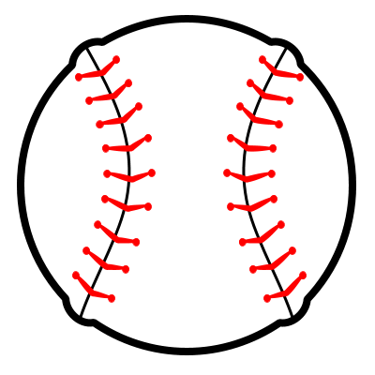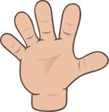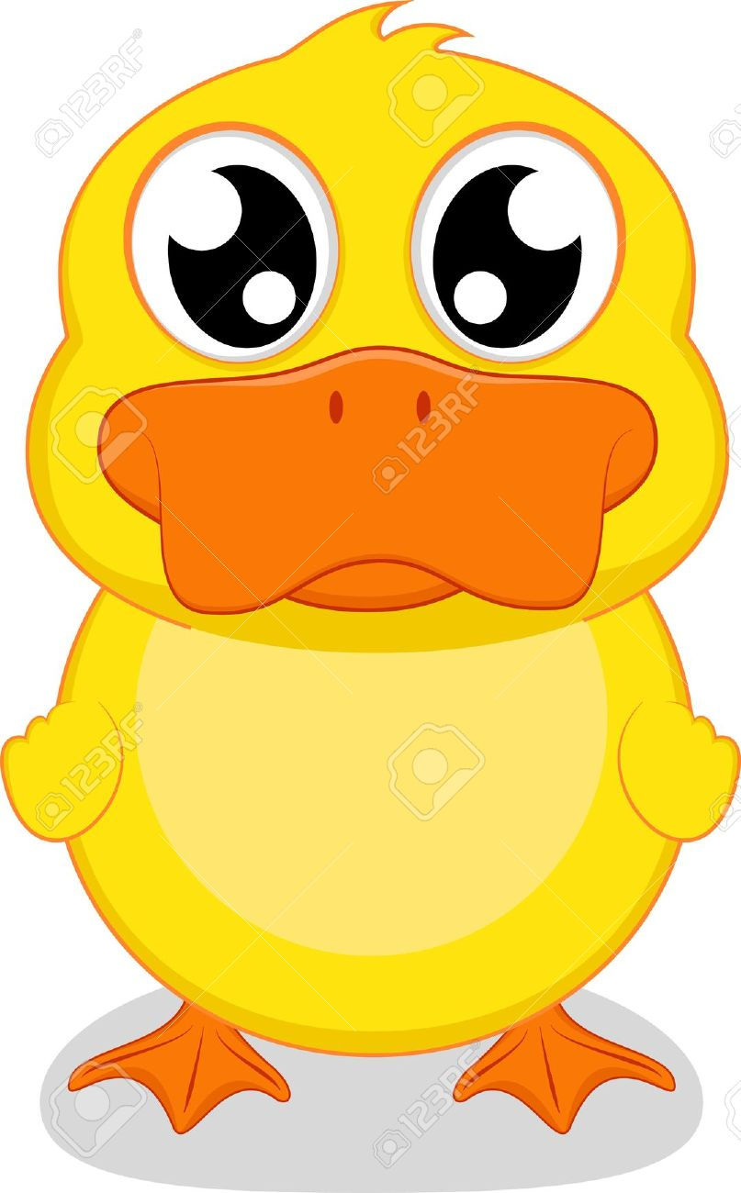

Duck moves left and right on its own.
Hand moves left and right with arrow keys.
Spacebar launched baseball straight up. Points are scored if it hits the duck.

You will get points for each feature you implement:

- (5 points) Launcher moves back and forth using the arrow keys.
- (5 points) Missile is “thrown” straight upwards when arrow key is pressed.
- (5 points) Score goes up when target is hit by missile.
- (5 points) Game gets more difficult as more points are scored.

You can also earn up to 5 points for attention to detail, and up to 5 points for creativity.

